# *Eimeria falciformis* and wild derived isolates from house mice: differences in parasite reproduction dynamics, host pathology and immune reactions

Al Klifeh, E.1,2; Balard, A.1,2; Jarquín-Diaz V.H.1,2; Martin P.2; Weyrich, A.3; Wibbelt, G.4; Heitlinger, E1,2.

1 Research Group Ecology and Evolution of molecular Parasite-Host Interactions, Leibniz Institute for Zoo and Wildlife Research, Alfred-Kowalke-Straße 17, 10315 Berlin, Germany.

2 Humboldt University, Institute for Biology, Dept. Molecular Parasitology, Philippstraße 13, 10115 Berlin, Germany.

3 Department Evolutionary Genetics, Leibniz Institute for Zoo and Wildlife Research, Alfred-Kowalke-Straße 17, 10315 Berlin, Germany.

3 Department Wildlife Diseases, Leibniz Institute for Zoo and Wildlife Research, Alfred-Kowalke-Straße 17, 10315 Berlin, Germany.

Parasitic infections with different species/strains of *Eimeria* (Apicomplexa:Coccidia) induce a dynamic range of host immune reactions and pathological lesions. To investigate the different dynamics of Eimeria infection, we infected NMRI mice with three strains of Eimeria, , two were recently isolated from wild rodents (W) (1) *E. flaciformis* (falW) and (2) *E. ferrisi* (ferW), and one has been kept under laboratory (L) conditions for roughly 60 years (3) *E. flaciformis* BayerHaberkorn (falL). For all three strains we investigated and compared the dynamic ranges of infection in regard to *Eimeria* reproduction success (by counts of *Eimeria* oocyst shedded in host faeces), host weight loss, cytokine gene expression profiles in mice spleen, tissue inflammation and cellular immune response (of the central segment of the caecum) .

Our results show that while reproduction and maximal weight loss is species-specific for *E. flaciformis* *vs.* *E. ferrisi*, surprisingly host cytokines` gene expression are at significantly higher levels in the lab strain (falL) compared to both wild-derived Eimeria species (falW and ferW). FalL still resembles a closely related wild derived isolate genetically and in infection dynamics, but differs in the immune response it induces. The controlled laboratory conditions of Eimeria falL proliferation by serial passaging of the parasite might have driven an evolution by artificial selection. To facilitate unbiased interpretations and repeatability of Eimeria studies, our results show that caution is needed when using laboratory strains of pathogens to draw conclusions about infections in natural systems as their infectious behaviour and influence varies.

In ferW after a pre-patency period of only 3 days, oocyst shedding peaks in intensity at 6 days post infection (dpi). In contrast, after pre-patency of 5 days, oocyst shedding of falL and falW show highest intensity at 8 dpi and 9 dpi, respectively. Concomitant impact on the host is parasite species-specific and maximal weight loss occurs before maximal oocyst shedding in infections with *E. ferrisi,* but after or simultaneously with maximal shedding in *E. falciformis* (both isolates). mRNA expression of the cytokines CxCL9, IL6, IL10 and IL12, TGFβ and the transcription activator STAT6 in the spleen is significantly increased in infections with falL. All those genes are detected at significantly lower levels in infections with the two wild derived isolates falW and ferW. Inflammation manifested in a mixed inflammatory response of eosinophilic granulocytes lymphocytes and plasma cells in the ceca and the extent of intestinal wall occupied by leukocyte infiltration is larger in infections with falL than in those with both wild derived isolates (falW and ferW).

We can conclude that NMRI mice mount a relatively stronger immune and inflammatory response against the laboratory isolate of *E. falciformis* compared to both wild derived lines of *E. falciformis* and *E. ferrisi*. It seems possible that evolution during laboratory passages produced a parasite isolate, which still resembles a closely related wild derived isolate genetically and in infection dynamics, but differs in the immune response it induces. Immune response against laboratory and wild derived isolates of *E. falciformis* differs to the extend, that the latter is more similar to the response against a different species of the parasite. In more general terms these result show that caution is needed when using laboratory strains of pathogens to draw conclusions about infections in natural systems.

**Introduction**

Maintenance of parasite life cycles via serial passaging is a cornerstone of experimental parasitology. Parasites are propagated under defined and controlled conditions with the aim to provide infective stages for experiments (Lucius and Loos-Frank, 2008). The procedure allows the parasite to evolve due to mutation and genetic drift or adaptation to the passaging host and environment (Burke, 2012). Genetic drift is promoted by the use of small inoculates during passaging and drift can act while diversity of a parasite isolate is reduced intentionally to obtain a clonal strain. In clonal strains mutation and drift can continue to act (Theron et al 2008; Chelo et al 2012). Considering adaptive evolution, an important part of the passaging environment is given by living hosts, or host cells (in case of propagation in culture), which usually have low genetic diversity (e.g., clonal or inbred lines, cultures) (Elena and Lenski, 2003), are immunologically naive due to the absence of previous infections (Mackinnon ‎2004; Abolins et al 2017) and lack co-infections with other parasites (Abolins et al 2017). Procedures for serial passaging of parasites typically collect infective stages at a particular time after infection and use the obtained inoculum to infect new animals or use haphazard infections in dense environments. Iteration of such a static routine may further differ from natural parasite environments with different timing of infections and variable transmission. In most cases both the biotic (host) and abiotic passaging environment thus differs profoundly from the environment experienced by the parasite during its life cycle under natural conditions. To summarize, parasite laboratory strains might experience both neutral and adaptive processes and as a consequence be unrepresentative for analogues in the field (Irschick and Reznick 2009).

Serial passage leads in most cases to higher virulence (enhanced growth and reproduction of the parasite and larger impact on the host), especially in the host type used for passaging (reviewed by Ebert, 1998, Garland and Rose 2009). This can be due to low genetic diversity in host populations (for example inbred line used for passage) that may reduce fitness trade-offs associated with specialization and promote the expansion of highly virulent pathogens. This phenomenon has been long demonstrated in several parasitic systems, such as in viruses (Kubinak et al., 2015), in plant pathogenic fungal parasites (Altermatt and Ebert, 2008), in vertebrate host-eukaryotic parasite systems like the apicomplexan parasite Plasmodium spp. in rodents (Mackinnon and Read, 1999 and ‎2004; Barclay et al, 2014) and in its mosquito vector (Pigeault et al., 2015), or common laboratory strains of Toxoplasma gondii (Khan et al. 2009). These studies collectively suggest adaptation to the passage host in a way that increases parasite virulence.

Consistent with this, serial passage of highly virulent isolates of the apicomplexan parasite Eimeria spp. can lead to attenuation when only the first oocystes committing to sexual reproductions are selected for the next passage ([Shirley](https://www.ncbi.nlm.nih.gov/pubmed/?term=Shirley%20MW%5BAuthor%5D&cauthor=true&cauthor_uid=3375582) and [Bellatti](https://www.ncbi.nlm.nih.gov/pubmed/?term=Bellatti%20MA%5BAuthor%5D&cauthor=true&cauthor_uid=3375582) 1988, [McDonald](https://www.ncbi.nlm.nih.gov/pubmed/?term=McDonald%20V%5BAuthor%5D&cauthor=true&cauthor_uid=6877863) and [Ballingall](https://www.ncbi.nlm.nih.gov/pubmed/?term=Ballingall%20S%5BAuthor%5D&cauthor=true&cauthor_uid=6877863) 1983, Matsubayashi et al, 2016). These attenuated strains are called “precocious lines” and are the basis for successful live vaccines used in the poultry industry (Shirley and Long, 1990, Shirley and Millard, 1986). Given the practical implications of this phenomenon, numerous serial passage experiments focused on changes in parasite life history that arise as a consequence of parasite adaptation to the passage host. It is surprising that only a few empirical studies attempt to correlate these evolutionary changes of attenuation or enhanced virulence in the parasite with physiological (e.g. immune) responses in the passaging host.

Species of the genus *Eimeria* have usually a small host range, often infecting a single host species (Hashimoto et al., 2014; Hnida and Duszynski, 1999; Kvičerová and Hypša, 2013; Vrba and Pakandl, 2015) and reside at specific sites within the intestines of their hosts (Chapman et al., 2013; Haberkorn, 1970; Owen, 1975). All species have a direct life cycle with asexual expansion and sexual reproduction within epithelial cells of the gastrointestinal tract before diploid transmission stages (oocysts) are released. Oocysts become infective after reductive divisions (sporulation) in the environment (Cacho et al., 2012; Canning and Anwar, 1968, Kheysin 1972).

*Eimeria* spp. are widespread in diverse host species including all vertebrates and coccidiosis in livestock has long been a focus of veterinary research due to the economic impact (Brake et al., 1997; Cacho et al., 2012; Gadde et al., 2009; Laurent et al., 2001; Swaggerty et al., 2011). *Eimeria* species capable of natural infection of the mouse (*Mus musculus*), the main model system of biomedical research, have been proposed as a model for e.g. host immune response against *Eimeria* (Heitlinger et al., 2014; Schmid et al., 2014). Serial passaging of laboratory isolates of *Eimeria* is conducted by collecting oocysts at the day of peak shedding, in case of the isolate *E. flaciformis* BayerHaberkorn (Haberkorn, 1970) 7 days post infection (dpi). Oocysts are sporulated in an aqueous solution of potassium dichromate and inocula are used for new infections two to six months later, before interactivity decreases (Ref). The isolate *E. flaciformis* BayerHaberkorn has been isolated in 1960 (Haberkorn 1970) and has been propagated in the laboratory for nearly 60 years through experimental passaging. It has been routinely used to assess basic immunological responses against *Eimeria* infections (Ehret et al., 2017; Pogonka et al., 2010; Schmid et al., 2014, 2012; Stange et al., 2012; Steinfelder et al., 2005).

Although normally controlled by the host immune system, and self-limiting even in immune-compromised hosts (Ehret et al., 2017), *Eimeria* infection can lead to a variety of outcomes in infected host for different host(?) species (Schito et al., 1996). After penetrating the intestine, Eimeria stimulate the production of cytokines, interleukins (IL) and interferon (IFN)-γ by immune cells. Several cytokines promote a strong Th1 response which limits parasite production (Byrnes et al., 1993; Laurent et al., 2001; Lillehoj, 1998; Lillehoj and Choi, 1998; Ovington et al., 1995; Rose et al., 1992). Previous studies have shown that an inflammatory reaction at the site of infection driven by IFNγ is dominant during *E. flaciformis* infection of mouse caecum (Schmid et al. 2014). And cytokines such as TGF-beta, EGF, IL-1 IL6 and IL10 in addition to the chemokines belonging to CXC and CCL family are up-regulated (Ehret et al., 2017; Schmid et al., 2012; Stange et al., 2012). To advance the understanding of this complex infection, both local and systemic studies are required, which complement and direct each other.

Systemic immune response during *E. flaciformis* infection of the mouse has not been studied in such detail. The spleen is in mammals a secondary lymphoid organ in which innate and adaptive immune responses are controlled (Bronte and Pittet, 2013). Therefore, gene expression in the spleen is commonly used as an indicator of systemic immune response during parasite infections (Mueller et al, 2007, Li et al, 2009; Burk et al 2010; Shen et al; 2015). Few studies have assessed the spleen in *Eimeria* infections e.g. via expression of cytokines. Steinfelder et al. (2005) showed that proliferated cells from spleen of *E. flaciformis* infected mice released IFNγ and IL4 and likely contribute to the development of a systemic humoral response in infected mice. E. tenellaantigen has been shown to induce IFNγ release in spleen cells of from immunized chickens (Prowse & Pallister, 1989). Similarly, Byrnes et al., 1993 illustrated the abilities of splenic macrophages to produce IL1 and TNFα during the primary infection of E. tenella and E. maxima. The expression of chicken Toll-like receptors (TLR3, TLR15), signal adaptor (MyD88) (Zhou et al., 2014) and IFNy (Rothwell et al., 2000) has been detected in the spleen of chickens as a response to infection with E. tenella.

In the 60 plus years since its isolation, the *E. flaciformis* Bayer Haberkorn isolate has become the most commonly used laboratory isolate of rodent *Eimeria*. In the present study, we compared infection of mice (NMRI) with the laboratory isolate *E. flaciformis* BayerHaberkorn (falL), wild derived isolates of *E. flaciformis* (falW) and *E. ferrisi* Levine and Evens, 1965 (ferW). We assessed similarities and differences in proliferation of tissue stages, oocyst shedding, induced pathological changes and immune response between two different *Eimeria* species and used these differences as a background to compare the laboratory isolate of *E. falciformis* (BayerHaberkonrn) with a novel field isolate of the same species.

## RESULTS

### Dynamics of infection and body weight loss differ between *Eimeria* species

We infected mice with three different *Eimeria* isolates and followed the progression of infection by measuring parasite reproduction and host body weight loss. We assessed parasite reproduction via oocyst shedding from two to eleven days after infection (dpi) (Figure 1a). The two *E. flaciformis* strains and *E. ferrisi* showed different infection dynamics in NMRI mice: oocyst shedding of *E. ferrisi* has a peak intensity at 6 dpi, which was drastically reduced on 7 dpi (n = 12, U = 2.91, p = 0.002) and fell below detection levels on 10 dpi. Oocyst shedding of *E. falciformis* has a peak intensity at 8 dpi for the laboratory isolate BayerHaberkorn (falL) and at 9 dpi for a novel, wild derived isolate (falW). The oocyst numbers declined after this peak in both isolates, but shedding was still detectable at 11 dpi when we ended the experiment and sacrificed all mice. For the two *E. falciformis* strains we observed no difference in shedding intensity of oocysts at the peak day (n = 12, U = 0.24, p = 0.846) and peak oocyst abundance did not differ significantly between *E. ferrisi* and both *E. flaciformis* strains (ferW *vs.* falW, n = 12, U = 0.32, p= 0.777; ferW *vs.* falL, n = 12, U = 0.96, p= 0.37).

The time of patency (oocyst shedding) was characterized by body weight loss in infected mice in all three investigated infection groups (Figure 1b). Infections with *E. ferrisi* coincided with significant weight loss at 4 dpi (n = 18, U = -2.43, p = 0.013) and 5 dpi (n = 18, U = - 2.52, p = 0.010) in comparison to the control group. Infection with *E. falciformis* was accompanied by significant weight loss at 8 and 9 dpi in both falL (both dpi, n = 12, U = -2.89, p = 0.002) and falW (8dpi, n = 12, U = -2.41, p = 0.013; 9dpi, n = 12, U = -2.89, p = 0.002) isolates as compared to the control group. Weight losses in infections with *E. ferrisi* at their maximum (at 5 dpi) were, however, significantly lower compared to weight loss in infections with *E. falciformis* at their maximum (9 dpi; ferW vs. falW, n = 15, U = -2.0, p = 0.049; ferW vs. falL, n = 15, U = -2.59, p = 0.007).

Oocyst shedding and weight loss show different relative timing in *E. falciformis* compared to *E. ferrisi*. In infections with both strains of *E. falciformis* weight loss coincides with or follows one to two days after oocyst shedding, in infection with *E. ferrisi* weight loss precedes peak oocyst shedding by one day or more.

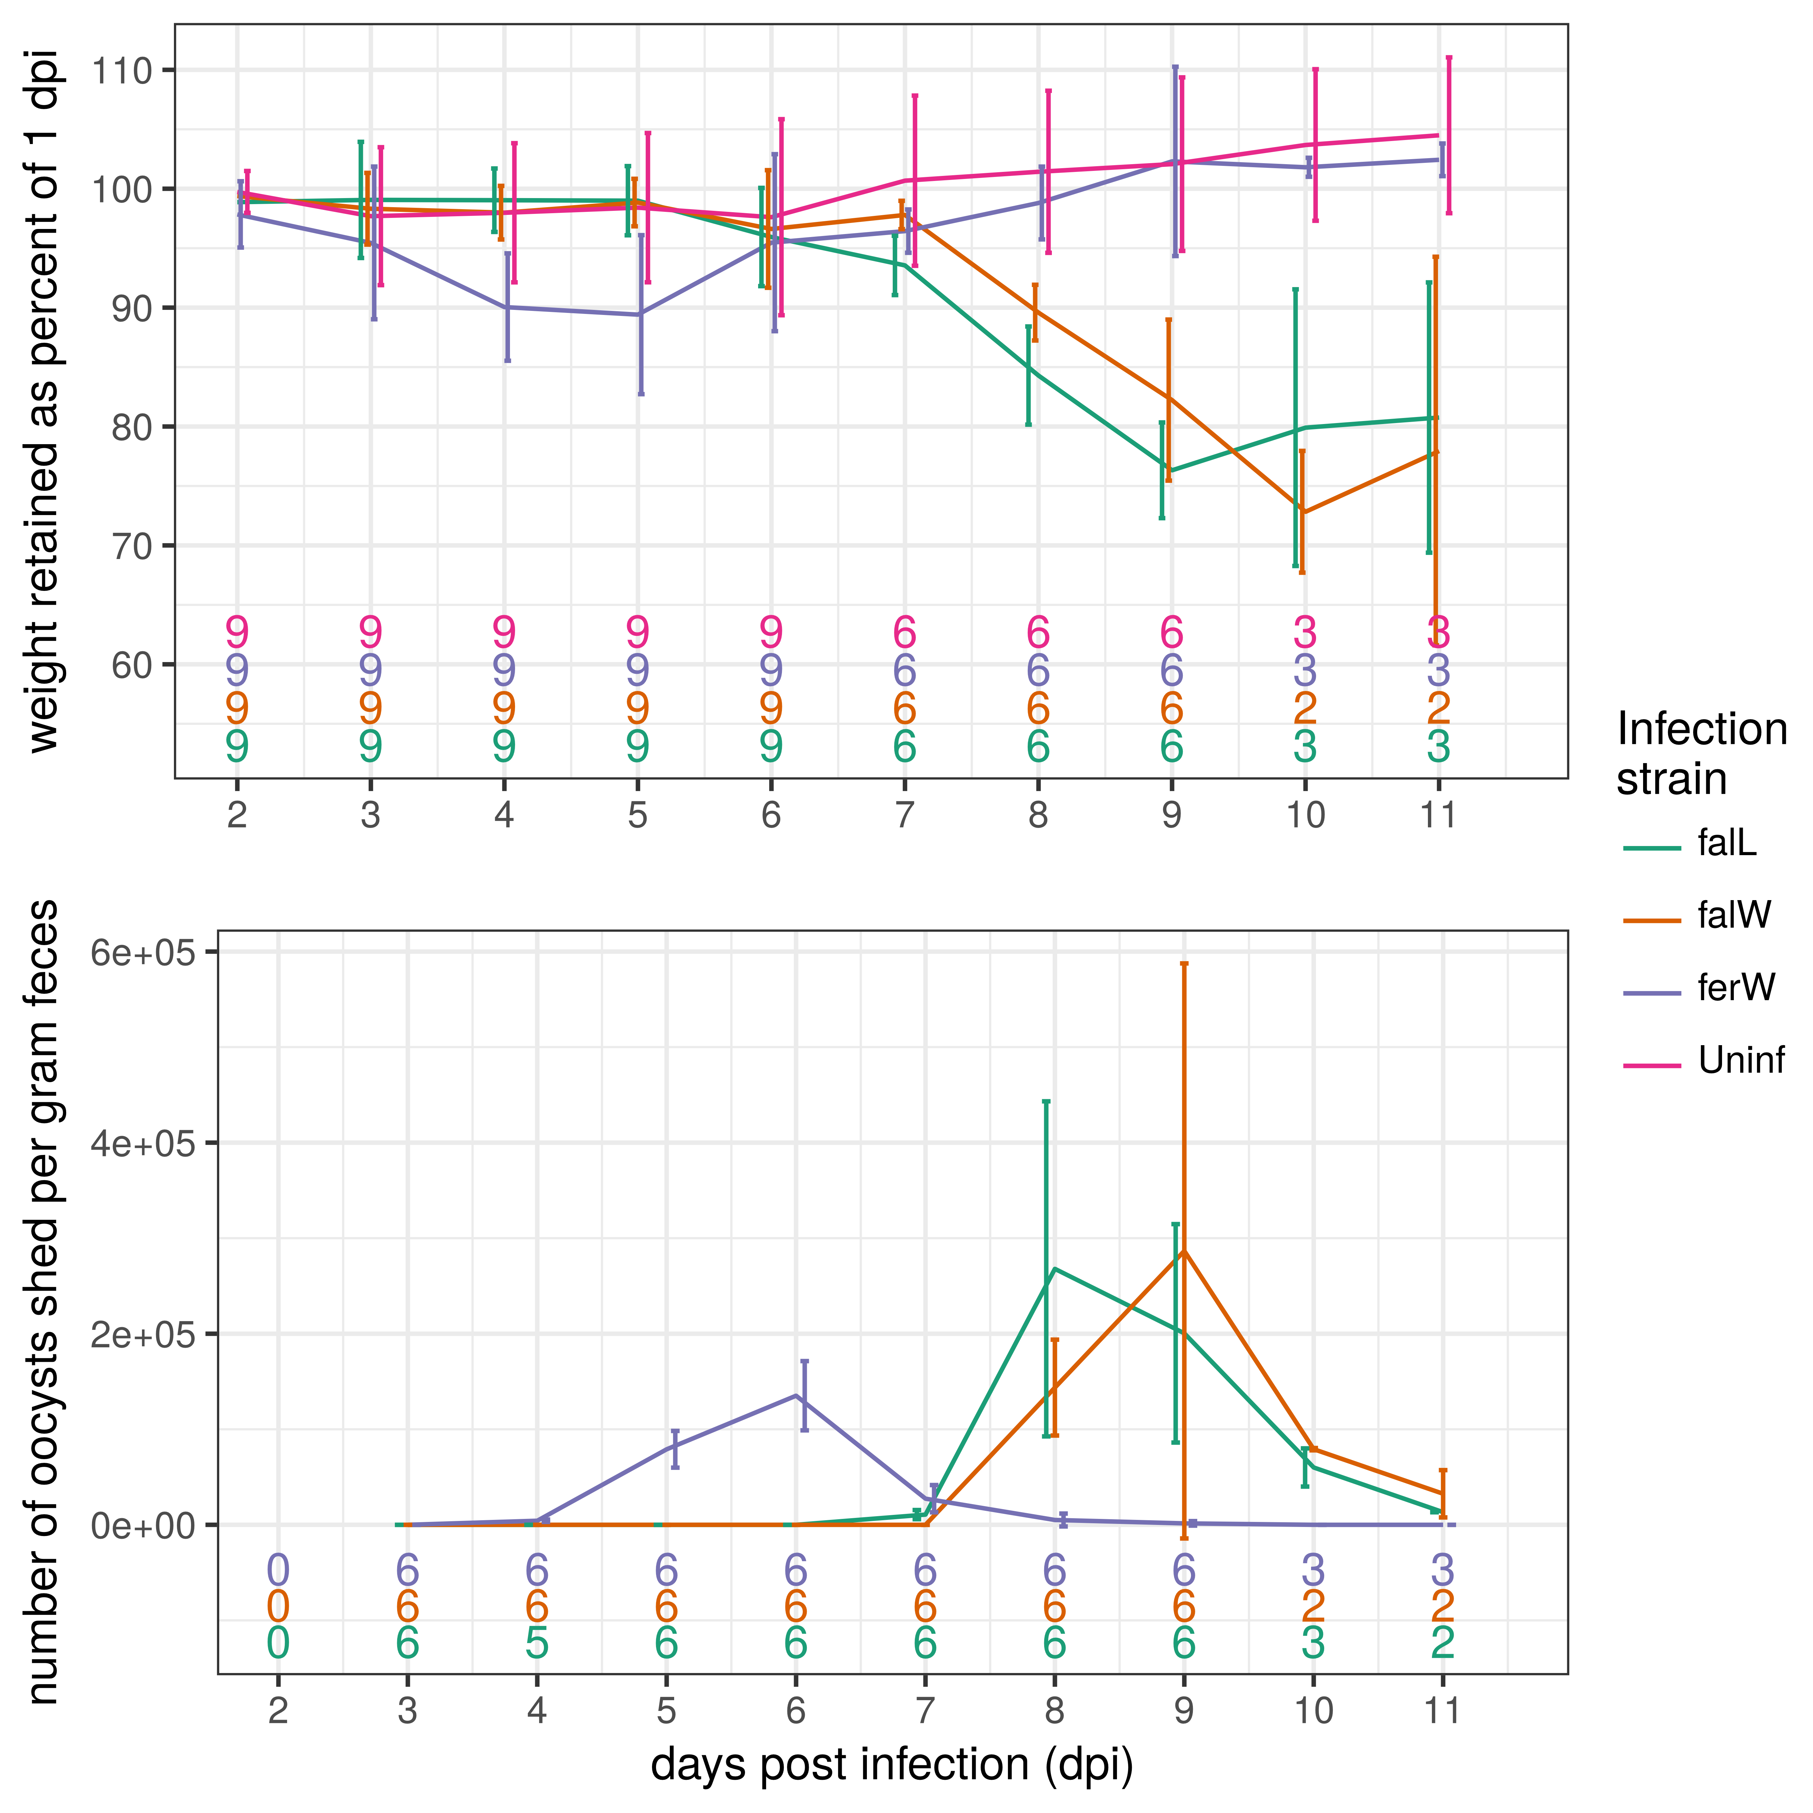

**Figure 1** – Dynamics of parasite reproduction and hosts’ weight loss differ between the species *E. falciformis* and *E. ferrisi*. a) Oocyst shedding of *Eimeria* spp. from experimentally infected mice (NMRI) is displayed from 1 to 11 days post infection (dpi). Mice were infected with 200 sporulated oocyst of *E. ferrisi* (a wild derived isolate; ferW) and *E. falciformis* (the laboratory isolate BayerHaberkorn; falL or a wild derived isolate; falW). b) Body weight loss of the same three groups of mice is depicted as percentage of body weight retained compared to 1 dpi. The number of mice (n) is given at the bottom of the plot, it is reduced at the end of the experiment, because mice were sacrificed for collection of tissue samples. Lines indicate the mean for each group, error bars give the standard deviation.

**Intensity of tissue stages of *Eimeria spp.***

*Eimeria* infections in our study resulted in a transient presence of parasite stages in epithelial cells of the caecum. The intensity of infection was quantified by quantitative PCR (qPCR) assay using caecal gDNA. By amplifying genes specific for the parasite (Cytochrome C-oxidase subunit I; COI) and the host (nuclear *cdc42* gene), we analysed the ratio of parasite DNA to host DNA. We report this ratio on a native (log2) scale of measurement and further call it the parasite-host DNA log-ratio (Figure 2a). The analysis of infected () and control samples (; (uninfected controls n = 13) allowed us to estimate a limit of detection (LOD; mean + 2 standard deviations of the negative controls) for the assay at a parasite-host DNA log-ratio of -3.73. This corresponds to roughly eight *Eimeria* COI molecules for 100 copies of the mouse nuclear genome. The highest value measured for an individual negative control sample was a parasite-host DNA log-ratio of -4.84. Maximum values for parasite-host DNA log-ratio (observed in the falL isolate) were 7.74 indicating a ratio of 214 parasite COI mDNA copies for each copy of the mouse genome in crude tissue at this point.

Given the low sample size we abstain from a statistical analysis of individual sampling days but describe the observed pattern (Figure 2a). While at 3 dpi *E. ferrisi* had the highest value of parasite-host DNA log-ratio (at 6.19), both *E. falciformis* isolates/strains were still below the limit of detection (for all falW and for two out of three falL samples). For *E. falciformis* (both isolates) parasite-host DNA log-ratio increased to values well above zero (equal numbers of parasite mitochondrial and host nuclear DNA copies) on 5 dpi. For both isolates of *E. falciformis* the highest values were reached at 7 dpi. Again the amount of DNA measured was similar to that of *E. ferrisi* (at 3 dpi). Except for one *E. ferrisi* outlier-sample, for which a value of 3.86 was measured, at 11 dpi the parasite-mouse DNA log-ratio was reduced to values below zero for all samples and for most samples below the limit of detection.

To test how this parasite-host DNA log-ratio predicts visible tissue stages we counted lesions parasite tissue stages in histological sections. In a generalized linear model (Table 1) the parasite-host DNA log-ratio is a significant predictor for the number of tissue stages (Figure 2b). The effect of the parasite-host DNA log-ratio is similar for both isolates of *E. falciformis*, meaning that a similar number of tissue stages are found for similar parasite-host DNA log-ratio in this species. For *E. ferrisi,* however, a significant interaction effect indicates that a lower number of tissue stages is found for similar DNA concentrations. Inspection of Figure 2b makes clear that for *E. ferrisi* early (3 dpi) parasite presence did not coincide with tissue stages.

**Table 1** – A generalized linear model predicts tissue lesions with the amount of parasite DNA relative to host DNA (parasite-host DNA log-ratio).

|  |  |  |  |  |
| --- | --- | --- | --- | --- |
|  |  | Lesion score | | |
|  |  | *Prediction* | *CI* | *p* |
| (Intercept) |  | 4.43 | 3.18 – 6.03 | <.001 |
| PH.delta |  | 1.55 | 1.48 – 1.64 | <.001 |
| Infection isolate | | | | |
| *Inf. falW* |  | 3.03 | 2.09 – 4.46 | <.001 |
| *Inf. ferW* |  | 2.23 | 1.45 – 3.42 | <.001 |
| PH.delta : Inf. falW |  | 0.90 | 0.84 – 0.95 | <.001 |
| PH.delta : Inf. ferW |  | 0.69 | 0.63 – 0.76 | <.001 |
| Observations |  | 33 | | |

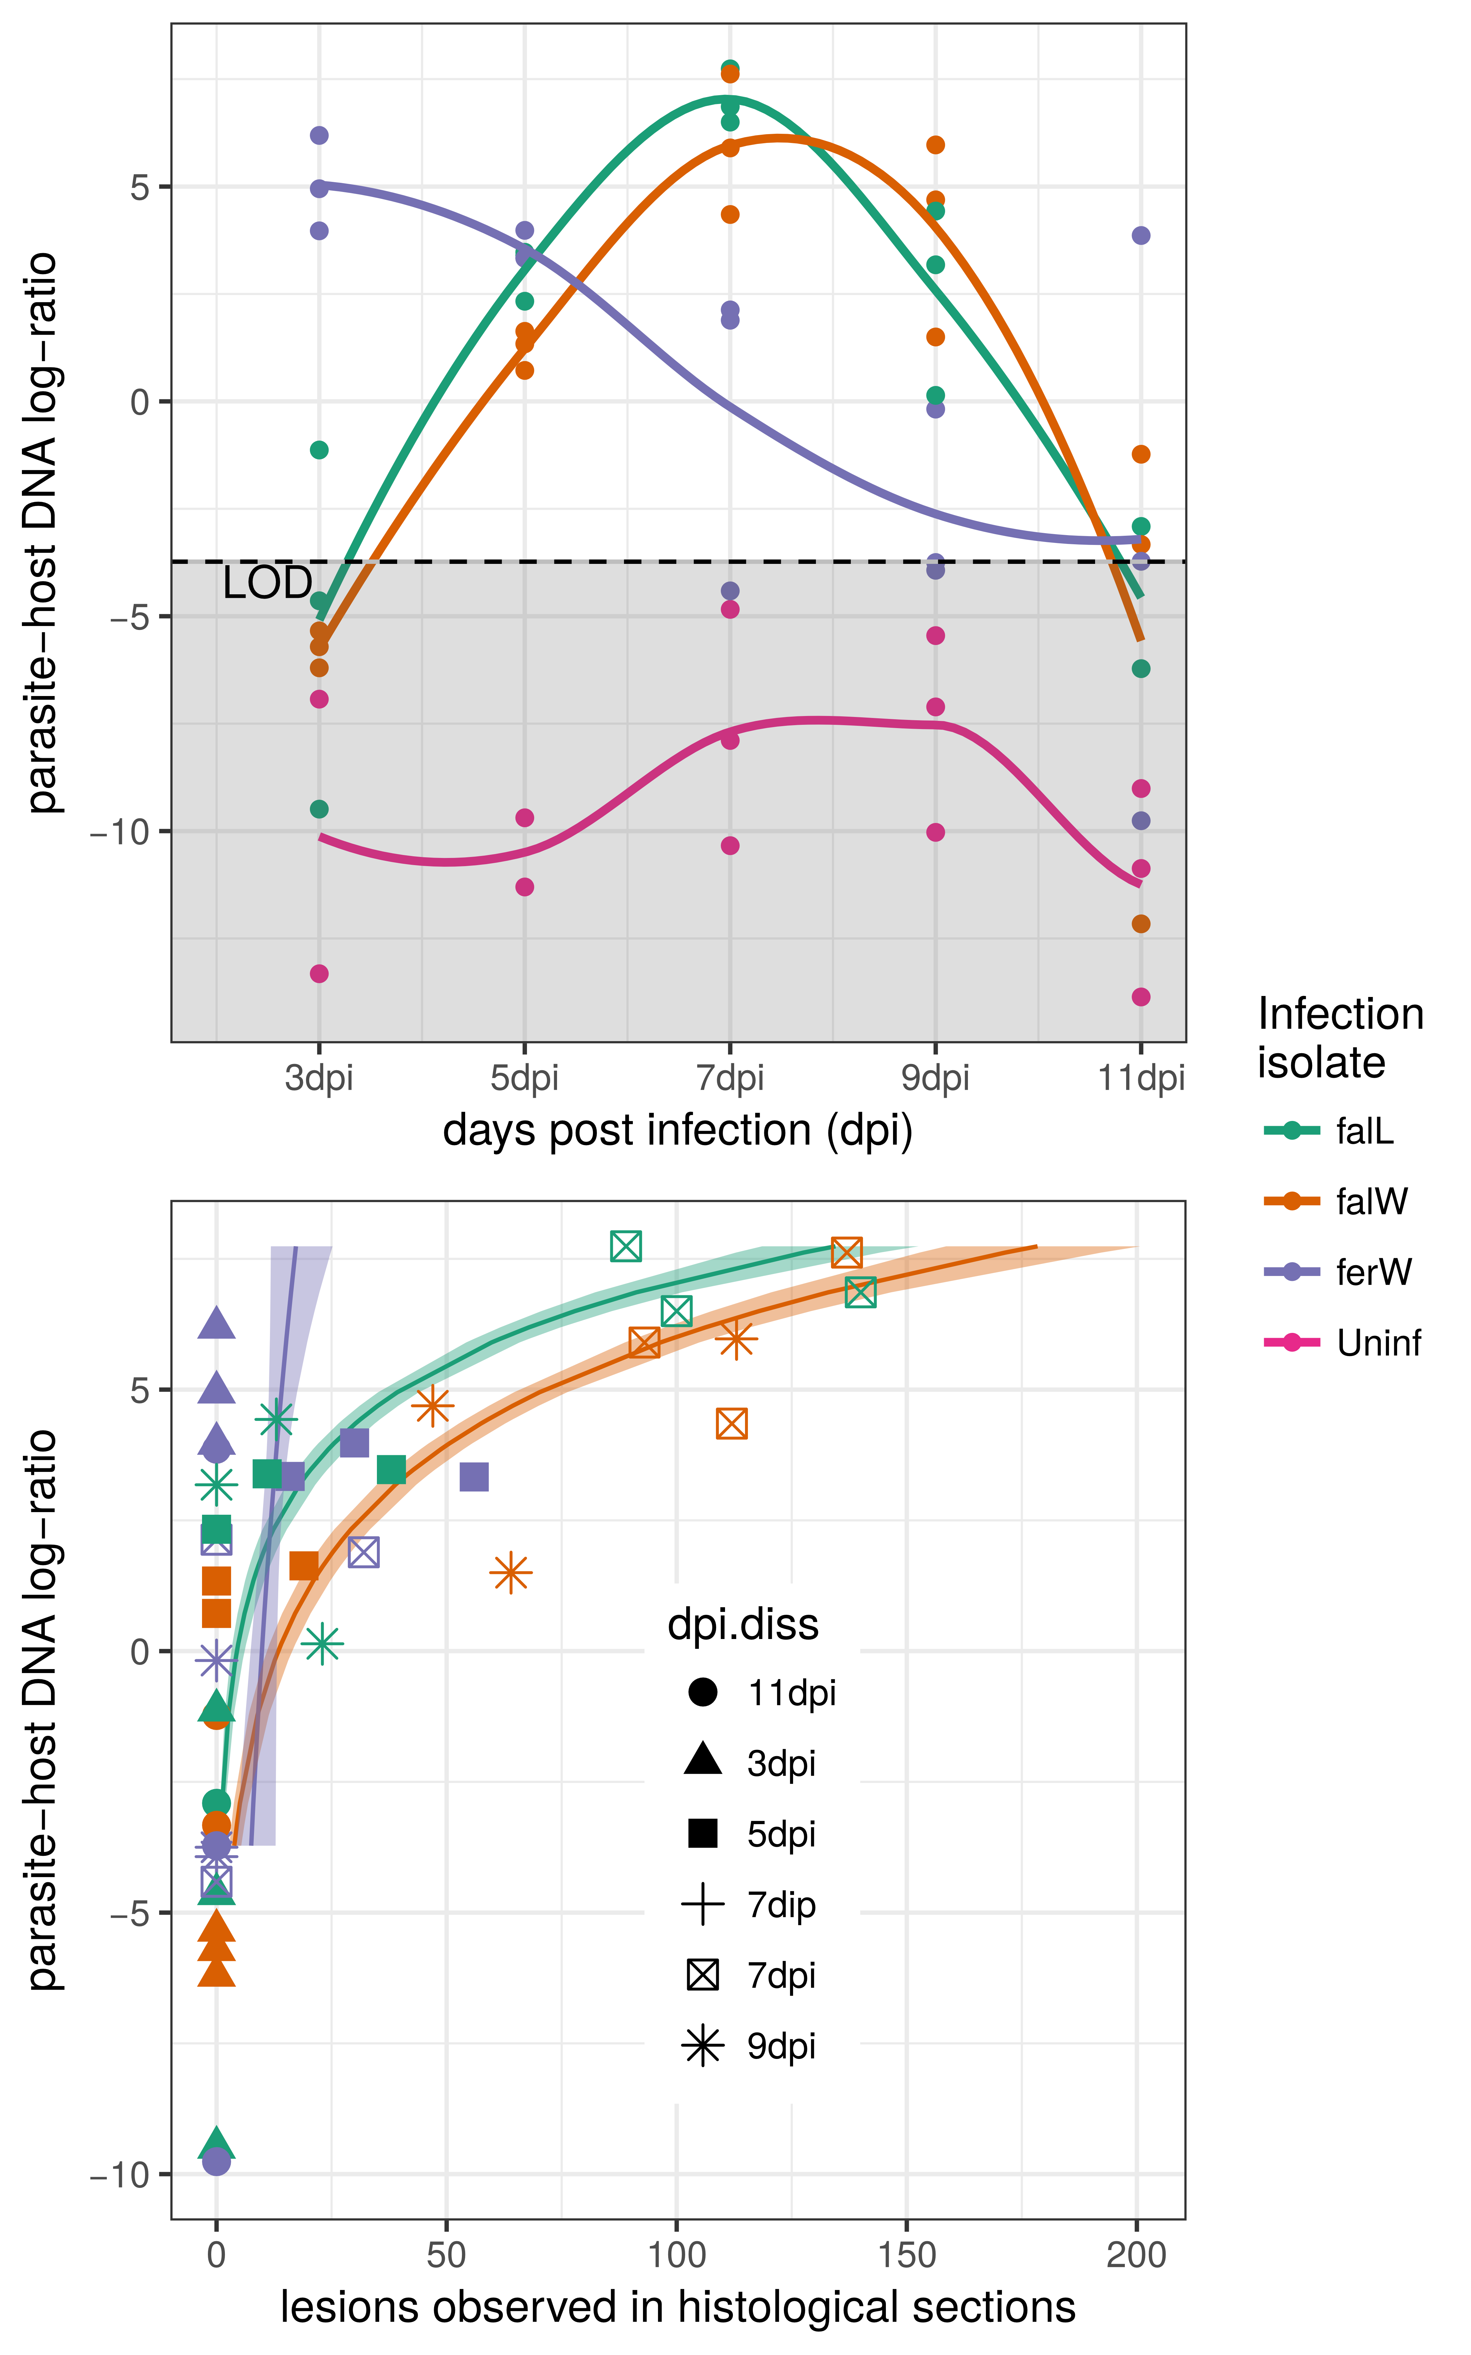

**Figure 2 –** The relative amount of parasite *vs.* host DNA (parasite-host DNA log-ratio) estimates the intensity of parasite caecum tissue stages. a) The parasite-host DNA log-ratio was calculated from the difference in cycle of threshold (Ct) values of qPCRs performed on a single copy nuclear gene (Cdc42) of the host and on a mitochondrial (COI) gene of the parasite. Lines are drawn using local polynomial regression fitting (a “loess smoother”). b) Predictions of parasitic tissue stages from these qPCR data are shown for all parasite isolates at different times after infections. Lines here represent predictions from a generalized linear model, shaded areas 95% confidence intervals of these predictions. For *E. falciformis* (falW and falL) this model provides better fit than for *E. ferrisi* (ferW).

**Differences in immune gene expression between the laboratory and wild-derived isolates**

To characterize the immune response of NMRI mice against the *Eimeria* isolates we studied the gene expression of relevant performed reverse transcription (RT) cytokines. Expression levels for most genes differed significantly between uninfected controls and mice infected with the *E. falciformis* laboratory (falL)isolate (Figure 3). We used linear mixed effect models with the dpi as random effect to “pool” information over multiple dpi, increasing sample sizes for comparisons. Mice infected with falL had significantly higher expression levels of chemokine 9 (CxCl9), interleukins 10 and 12 (Il10 and Il12), tumour growth factor beta (Tgfβ), and signal transducer and activator of transcription 6 (Stat6). We did not detect significant expression differences between control and falL infected mice for interleukin 6 (Il6), interferon gamma (Ifnγ) and tumour necrosis factor alpha (Tnfα). Results differed for both wild-derived strains. Here expression levels for any of the examined genes did not differ significantly between uninfected and infected mice. Immune gene expression in infections with the laboratory (falL) isolate showed to be significantly higher than in infections with wild parasite isolates (ferW and falW) (Table 2). Some genes showed differences in gene expression profiles over the course of infection, in some cases including differences between infections with different parasite isolates (Figure 3). We did not analyse differences on individual days statistically due to the low sample sizes, but give a description of our observations. Il6 showed elevated levels of expression for all infection groups compared to controls as early at 5 dpi. Expression levels for Ifnγ seemed elevated only at 5 dpi and only in infections with the *E. falciformis* laboratory isolate (falL). Both cases of potential elevations in expression failed to be detected as significant over controls in our mixed effect models because it was very transient and diminished already at 7 dpi. The interleukins Il10 and Il12 as well as Stat6 and CxCl9 showed elevated expression levels at multiple days of infection for the falL compared to all other infection groups. *TGFβ* showed somewhat elevated expression levels early in infection with EferW (3 and 5 dpi) and late in infections with EfalL (7 and 9 dpi). For Tnfα we observed elevated expression levels in all infected but also in uninfected control groups. Taken together these observations add detail on the individual cytokines and underline our general finding of differences between wild-derived and laboratory isolates of *E. falciformis*.

In summary expression of genes relevant for immune responses did not differ significantly from uninfected controls during infection with wild derived isolates of both *E. falciformis* (falW) and *E. ferrisi* (falL). In contrast, most genes were expressed significantly higher in infections with the laboratory isolate of *E. falciformis* compared to uninfected controls but also to all other infections including those with the wild derived *E. falciformis* (falW) isolate*.*

**Table 2** – Generalized linear mixed effect models show gene expression differences between wild (falW) and laboratory (falL) isolates of *Eimeria falciformis.* This table is submitted as separate file.

**Figure 3** – Hosts infected with wild and laboratory isolate of *E. falciformis* show different patterns of gene expression in the spleen. Mice were sacrificed at different time points post infection and mRNA expression was assessed using quantitative PCRs. Dots indicate normalized expression values for individual mice. Lines are drawn using local polynomial regression fitting (a “loess smoother”).

**Inflammatory cell infiltration differs between *E. falciformis* isolates**

To link our observation of gene expression with independent measures of immune response and pathological changes, we performed a histological scoring of inflammatory cell infiltration (Table 3, Figure 4). No infiltration of leukocytes was observed in uninfected control mice besides a few exceptions with very low infiltration. Alternative: Uninfected mice did not have any inflammatory cell infiltration, besides a few (n= xx) exceptions with very low numbers of infiltrating cells. In mice infected with the laboratory isolate of *E. falciformis* a relatively high score of inflammation was already observed during pre-patency (at 5 dpi), the extent of immune infiltration remained high until 9 dpi and declined towards 11 dpi. In contrast, in caeca of mice infected with thewild derived *E. falciformis* isolate only low numbers of inflammatory cells were found in the pre-patent period. Infiltration consisted mainly of lymphocytes and plasma cells at this stage of infection. Inflammation then increased at 7 dpi onwards, and during this period, eosinophilic granulocytes were also detected. Infiltration was marked at 9 dpi before decreasing slightly towards 11 dpi.

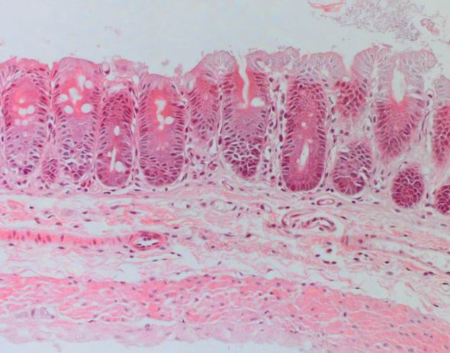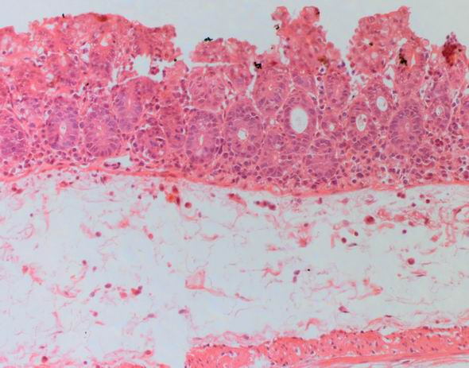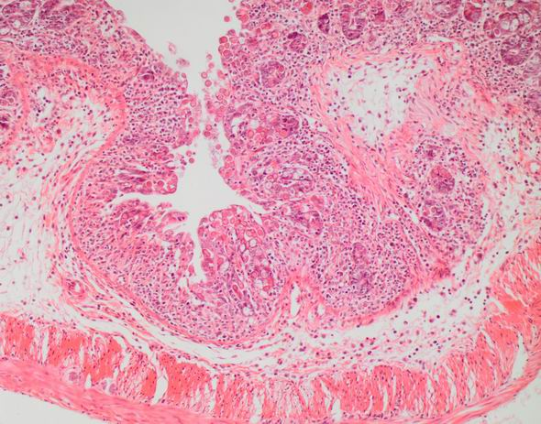

The quality of the observed infiltration was the same in both infections with wild derived and laboratory isolate of *E. falciformis*. Infiltrations are consistently characterised by both and the presence of eosinophils.

In infections with *E. ferrisi* a milder inflammatory resonse was detected on 3 dpi and 5 dpi. The strongest infiltration was detected at 5 dpi followed by a subsequent decline towards 7 dpi. We used information of mice sacrificed at different days during the infection in mixed effect models. Overall inflammation was significantly lower in *E. ferresi* infected mice than in those infected with *E. falciformis* (glmm; falL *vs.* ferW p = 0.001; falW *vs*. ferW p = 0.014).

**Table 3 - Score for the relative severity of leukocyte infiltration in sections from the mid-part of the caecum from NMRI mice infected with Eimeria spp.**

|  |  |  |  |  |  |
| --- | --- | --- | --- | --- | --- |
| Treatment¹ | Relative severity of leukocyte infiltration in caecum1 | | | | |
| 3dpi | 5dpi | 7pdi | 9dpi | 11dpi |
| ***E. ferrisi* (ferW)** | 2, 1, 1 | 1, 2, 2 | 1, 2, 1 | 1, 1, 1 | 0, 0, 0 |
| ***E.falciformis* (falW)** | 0, 1, 1 | 1, 0, 1 | 2, 2, 2 | 3, 2, 3 | 2, 2 |
| ***E.falciformis* (falL)** | 1, 2, 1 | 3, 3, 3 | 3, 3, 2 | 3, 3, 2 | 1, 1 |

1Leukocyte infiltration was scored on a 0 to 3 scale, where 0 represent no infiltration and 1, 2, 3 represented low, moderate, or high infiltration, respectively. One section from each of the caecum was used for scoring. Each section was subdivided into three low magnification fields, and infiltration revealed a mixture of mononuclear and cells. A numerical score was assigned to each section by averaging three low magnification fields. For each infection group and, values are reported for three mice.

**Discussion**

In the present study we evaluated whether wild-derived isolates of Eimeria spp. differ in infection dynamics, the immune reactions and in the pathological changes they induce from those of Eimeria falciformis BayerHaberkorn (Haberkorn, 1970), a classical laboratory isolate. We found differences in parasite reproduction dynamics between Eimeria species (E. falciformis vs. E. ferrisi). While such differences between species are expected, we also found differences between wild derived isolates of E. falciformis and the laboratory isolate of E. falciformis. The laboratory isolate of E. falciformis induces relatively stronger immune reactions and pathologic changes in NMRI mice than wild-derived isolates of both E. ferrisi and E. falciformis.

Between the two E. falciformis isolates we observed only slight differences in the length of the pre-patent period (time until oocyst shedding, starting at 6 vs. 7 dpi). These results are in agreement with previous reports from the same host (NMRI mice) and parasite isolates (Ehret et al., 2017; Schmid et al., 2014, 2012; Stange et al., 2012). The pre-patent period for the wild derived E. falciformis isolate (7 dpi) corresponds to that reported for the parasite isolate E. falciformis var praghensis (Kasai et al., 1991; Mesfin et al., 1978). Finally, Mahrt and Shi (1988) and Schito et al. (1996) demonstrated slightly longer pre-patent periods for E. falciformis infections (7 or 8 dpi).In future research we recommend a detailed reportof Eimeria isolate identity, and a careful monitoring of the pre-patent time between two isolates of E. falciformis. Similarly, the output of oocysts in our study (for all isolates) was comparable or slightly lower to that in previous reports (Ehret et al., 2017; Schmid et al., 2014).

Our observation regarding the infection dynamics of E. ferrisi, agree with the initial description of the life cycle in Mus musculus (Ankrom et al., 1975). Our present work confirms that E. ferrisi is characterized by a – especially when compared to *E. falciformis* – short life cycle with patency at 3 dpi. It is also noteworthy that the oocysts output of this species did not differ significantly when compared to that of both E. falciformis isolates (Figure 2), although this might be a result of the low sample size especially at late times of infection (when highest number of E. falciformis oocystswere shedded, but most mice had already been sacrificed).

Pathogenicity assessed by maximal weight loss during infections with *E. falciformis* was very severe in the present study compared to previous experiments (Ehret et al., 2017; Schmid et al., 2012; Stange et al., 2012). A potential reason for this is an elevated pathology induced by a variation in the inoculum dose. As observed by Haberkorn (1970) higher dosed inocula lead to enhanced pathology, while infection dynamics (the extent and timing of oocyst shedding) are not impacted. In *E. falciformis* infections maximal weight loss was observed at 9 dpi, while infections with *E. ferrisi* induced a significantly lower maximal weight loss at 5 dpi. These observations are likely due to fewer cycles of asexual merogony of the parasite leading to a lower burden of intestinal stages (Ref. missing). Interestingly, lines of poultry *Eimeria* with an abbreviated and early life cycle (so called “precocious lines”) show low oocyst output and are less pathogenic to their host (Shirley and Harvey, 2000; Shirley and Long, 1990). While *E. ferrisi* attains substantial oocyst output, it shares this low pathology with precocious lines. This suggests that short phases of asexual expansion might be correlated with low pathogenicity in *Eimeria* infections independent of total oocyst shedding. In other words, parasite fitness for “naturally precocious” species of *Eimeria* might be high, while simultaneously host fitness is relatively little reduced by infections.

Infection with Eimeria causes damage in the intestinal mucosa resulting in malabsorption of nutrients and weight loss (Chapman et al., 2013; Haberkorn, 1970). Interestingly, comparing of weight loss between the two isolates of E. falciformis and that of E. ferrisi demonstrate that E. ferrisi induces most weight loss before the peak of its oocyst shedding, while both E. falciformis isolates impact the host after the peak of their oocyst shedding (Figure 5).

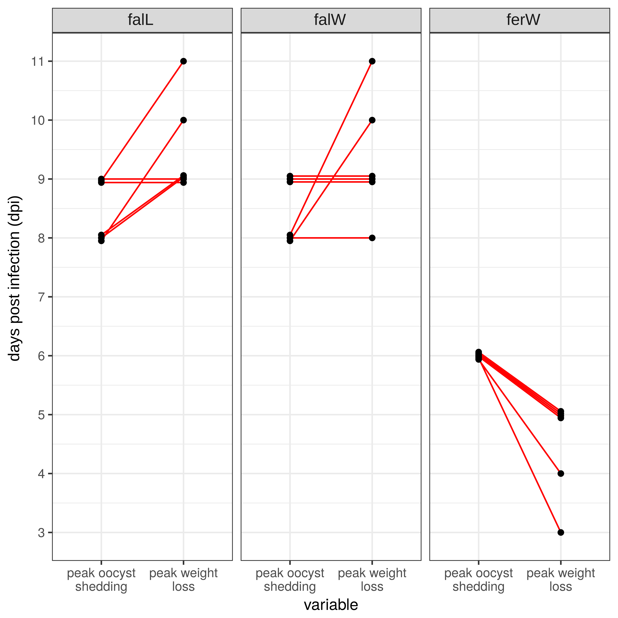

**Figure 5** – The peak of the host weight loss precedes the peak of oocyst shedding in infections with E. ferrisi, while in infections with E. falciformis the host lost most weight either on the day or after the days parasites shed most oocysts. Points depict the peak day of both oocyst shedding and weight loss respectively and red lines connect both measurement from the same mouse. For raw data and underlying experimental procedures see Figure 1.

These differences suggest that mechanisms underlying pathogenesis might be different between the two parasite species. Weight loss in infections with two isolates of E. falciformis occurs simultaneously with and reaches its maximum at or after sexual reproduction of the parasite (Ref. missing). Sexual reproduction of E. falciformis might cause an exhaust of epithelial cell which burst when oocysts are released into the lumen (Kasai et al., 1991). Additionally, histology indicates that weight loss coincides with immune cell influx in E. falciformis infections. This influx differed slightly in timing starting at 5 dpi in the E. falciformis laboratory isolate and 7dpi in the field isolate. Influx of immune cells into the tissue might be associated with immunopathology (Baskin et al., 2009; Brant et al., 2014; Stange et al., 2012). Maximal intensity of tissue stages (assessed using a qPCR assay, we established in the present study and counts of histological lesions) precedes for the two E.falciformis strains the release of oocysts from tissues into the intestine and maximal weight loss. For infection with E. ferrisi, in contrast, weight loss coincides with the peak abundance of endogenous stages at 3 dpi (Figure 2). It can thus be speculated whether it is simply the extraction of energy of E. ferrisi for its own growth causing pathology in this system. Intensity of tissue stages also coincides with immune cell activation at the site of infection and weight loss, suggesting that parasite proliferation cause pathology in host infected with this species.

Our histological analysis link weight loss pathology to tissue damage and can also validate our qPCR approach and measurements of parasite-host DNA log-ratio derived from it. We observed more lesions and stronger immune cell infiltration in infections with the laboratory isolate of *E. falciformis* than in the wild derived isolate. The number of Eimerial tissue stages over different dpi correlated well with the parasite-host log-ratio for these isolates. Infections with *E. ferrisi* were characterised by yet lower immune cell infiltration and tissue damage. In infections with this species the parasite-host DNA log-ratio seems to be more sensitive than the histological counting of lesions, which can hardly be observed.

Cellular infiltrations observed within the mucosa during experimental infections of *Eimeria* in many host species including mice have been described by several authors (Gadde et al., 2009; Laurent et al., 2001; Mesfin et al., 1978; Muñoz-Caro et al., 2016; Rose et al., 1992; Schmid et al., 2014). Tissue lesions are considered to be mostly caused by parasites directly, but inflammatory reactions contribute to the process (Muñoz-Caro et al., 2016). In this context, the relatively modest pathology (weight loss) observed during E. ferrisi infection might be a cause or consequence of milder immune cell infiltration observed in the infected tissues of this species.

Schmid et al. (2014) demonstrated by immunohistochemical analyses that *E. falciformis* infection in the caecum of NMRI mice leads to tissue infiltration with lymphocytes and macrophages. These changes are accompanied by elevated expression of INFγ and the production of the major chemokines CxC subfamily at the site of infection. Several authors before had described the role of INFγ and these chemokines to leukocyte attraction and its likely involvement in controlling the growth of *Eimeria* in mouse models (Lillehoj, 1998; Pogonka et al., 2010; Rose, 1974) and in *Eimeria* infected chickens (Laurent et al., 2001; Lowenthal et al., 1997; Yun et al., 2000). Inflammatory infiltrates were also slightly more prominent in our experiment in the laboratory isolate of *E. falciformis (*EfalL) than in closely related wild derived *E. falciformis* isolate (*EfalW*) and we thus asked whether systemic immune response differs between infections.

To investigate a more systemic immune response during infection we measured the expression of pro- and anti-inflammatory cytokines and regulatory chemokines in the spleen. Eight markers for different immune response pathways were investigated: CxCL9 is a major immune-regulator, INFγ and TNFα represent the innate pro-inflammatory response (Mosmann et al., 1986). IL12is a marker for Th1-type response against intracellular parasites (Ref), STAT6 for a Th2-type response (Ref). IL6 is a marker for the Th17pathway in the mucosal barrier tissues (Ref), and finally, IL10 and TGFβ have anti-inflammatory roles (reviewed in Terner *et al*, 2014, Stenger and Röllingho 2001).

Only the laboratory isolate of E. falciformis significantly influences the mRNA expression levels of most of these markers in the spleen. The wild derived isolates of E. falciformis and E. ferrisi do not induce expression changes over control levels.

An exception is the Il6 gene expression. Early in infection, Il6was elevated over control (although not significantly) in host spleens infected with each of the three Eimeria isolates . Il6 synthesized in the initial stage of inflammation at a local lesion, and then moves through the bloodstream to the liver and spleen (Hienrich et al, 1990). There, it promotes specific differentiation of naïve CD4+ T cells, linking innate to acquired immune response (Tanaka et al, 2014). Beyond its immune-regulatory function IL6 has a role in stimulating the intestinal epithelial proliferation and repair after injury. Thus an elevated level might be a consequence of parasite tissue damage (Kuhn et al., 2014). In experimental infections of mice with *E. falciformis* marked induction of Il6 transcription between 5 and 7 dpi has been reported at the site of infection (Ehret et al., 2017). In the present study Il6 is the only cytokine showing potentially enhanced expression also in the spleen. This might suggest that the immune modulatory role of IL6 in the spleen during *Eimeria* infections could be augmented by elevated mRNA expression within this organ.

We observed elevated mRNA levels of pro-inflammatory Th1 cytokines IFNγ, TNFα and IL12 in the spleens of mice infected with the laboratory isolate of *E. falciformis*. Our data from the spleen mirrors previously published data indicating an induction of these genes at the site of infection between 5 and 7 dpi (Ehret et al., 2017; Schmid et al., 2014). The IL12/IFNγ axis is crucial for the activation of cellular immune responses against intracellular parasites including Eimeria (Cacho et al., 2012; Chow et al., 2011; Ehigiator et al., 2007; Heinzel et al., 1991; Kulkarni et al., 2011; Lillehoj, 1998; Michailowsky et al., 2001; Ovington and Smith, 1992; Rose et al., 1992).

An increase in the expression of TNFα of was detected in all experimental groups, including the non-infected control group, around 5 dpi. This might be due to a stress response during the course of experiment. TNFα cellular responses involved in systemic inflammation that stimulate the acute phase reaction (Turner et al, 2014) can eradicate infectious agents, but can also lead to harmful systemic effects (Waters et al, 2013).

We observed significantly increased expression of the anti-inflammatory Th1 cytokines IL10 and TGFβ in infections with the laboratory isolate of E*. falciformis*. IL10 can counteract with IFNγ and is also expressed in *Eimeria*-infected spleens of chicken(Rothwell et al., 2000). IL10 expression in the spleen could be indicative for an attempt to balance inflammation during *E. flaciformis* laboratory isolate infection. A failure to established this inflammatory balance can lead to pronounced inflammation (Inagaki-Ohara et al., 2006). Tgfβ showed elevated expression levels early in infection with E. ferrisi (3 and 5 dpi) and late in infections with the *E. falciformis* laboratory isolate (7 and 9 dpi). The simultaneous elevation of Il6 expression levels, may indicate the involvement of a Th17 pathway to control the infection events. Tgfβ and Il6 play crucial roles in the generation of IL17 from naïve CD4+ T cells of mouse (Sehrawat and Rouse, 2017; Korn et al, 2009). IL17 in turn contributes to both immunopathology and parasite restriction during infection with *E. falciformis* (Stange, 2013).

In the spleen, induction of Stat6 expression has been reported in several infections with intestinal parasites (Lee et al., 2013, Lopez et al, 2013). In addition to elevated expression of Stat6 we noticed significantly elevated expression of the major regulatory chemokines CxCL9 in infections with the laboratory isolate of *E. falciformis*. CxCL9 can be induced downstream of INFγ (Djamiatun et al., 2017; Hirako et al., 2016; Schmid et al., 2014) and is involved in recruitment and activation of effector T lymphocytes in the spleen as well as in non-lymphoid organs such as intestine in disease models including *E. falciformis* (Hardison et al., 2006; Khan et al., 2001; Schmid et al., 2014).

The apparent differences in immune response of the wild-derived and the laboratory isolate of *E. falciformis* invites to speculate about their origin. Unfortunately, we do not know the infection phenotype (pathology) of the original *E. falciformis* BayerHaberkorn isolate 60 years ago. It is plausible, however, that the pathology before serial passaging resembled that observed in our isolate. In the laboratory the consequences of serial passaging can be seen as a selection experiment (Ebert, 1998). In Eimeria artificial selection has been used to e.g. create attenuated “precoccious” stains, which undergo a faster development, are less pathogenic but still induce protective immunity against reinfections (McDonald and Ballingall, 1983; Shirley and Bellatti, 1988).

Independent of the ultimate reasons for the difference in immunogenicity, we conclude that the infections with the laboratory isolate E. falciformis might not be representative for parasite-host interaction in their ecological and evolutionary context. In addition to the description of infection dynamics, induced immune reactions and histopathology for a wild derived isolate of E. falciformis in comparison to the BayerHaberkorn, we show that E. ferrisi possesses a short developmental cycle and low pathology. The characterisation of different Eimeria strains within the current study, including the Eimeria life cycle (Ankrom et al., 1975), histopathology and immune gene reactions mayincrease the attraction of this species as a rodent infection model for Eimeria.

**3. Material and Methods**

**3.1. Wild isolate of *E. flaciformis* (falW) and *E. ferrisi* (ferW)**

The pure inocula of *E. falciformis* (falW) and *E. ferrisi* (ferW) wild derived isolates were produced in our lab through NMRI infection experiment. Briefly, sporulated oocysts of *Eimeria* were recovered Berlin in 2016 from samples obtained after field collection from the house mouse hybrid zone north of, from individual faeces sample in which each genotype predominated 300 oocysts for E64 and 600 oocysts for Efwild were inoculated into 16 weeks old -NMRI female. All mice were reared individually in wire cages in isolation rooms and provided with food and water *ad libitum*. The faeces from those mice were collected daily during the period of oocyst release from 1 to 12 days post-inoculation [dpi]. Oocysts in faeces were harvested by screening, sedimentation- flotation in saturated NaCl salt solution, and washings. They were then placed in 2% potassium dichromate and incubated at 25 °C for 4 days to permit oocyst sporulation. Sporulated oocysts were examined repeatedly under light microscopy to ensure their purity, and were then stored at 4 °C for about 1 month prior to use.

**3.2. Infection protocol, oocyst counting and sample collection:**

The cleaned inocula of the wild derived *E. flaciformis* (falW) and *E. ferrisi* (ferW) isolates produced from the previously described experiment. The inoculum of *E. flaciformis* was originally by Haberkorn in 1960 and was since propagated through experimental passaging in NMRI mice every 3 months.

15 female NMRI mice (10 to 12 weeks old) were randomly assigned to four groups each, including a control group that was not inoculated. The remaining 45 mice were inoculated via oral gavage with 0.1 ml of inoculum containing a single dose of 200 sporulated oocysts. The inoculum had been prepared counting the total number of oocysts in 10µl directly on a standard microscope slide.

All faeces were collected every day of the experiment. After weighing the faeces, flotation was performed: Saturated salt (NaCl) solution was added, the mixture was stirred and centrifuged at 3175g. It was washed twice with physiological NaCl solution and after the last washing 2ml of 2% potassium dichromate solution were added to the pellet and 10µl of the solution were loaded into a “Neubauer-improved chamber”. Oocysts were counted in eight grid squares. Then the number of oocysts per gram faeces was obtained according to the (0.1µl) volume of a grid square: *Concentration (oocyst/g) = total #of oocyst / #squares counted \** *10.000 ml-1 * 2ml / g (faeces)*

During the 11 days of the experiment the body weight of each mouse was recorded every day . From each group three mice were sacrificed on 3, 5, 7, 9, and 11 dpi. Immediately after death the viscera were exenterated and spleen and caeca removed. Caecal contents were gently removed with physiological NaCl solution and the tissue was cut longitudinally into two pieces. One piece was transferred into a 30 ml tube containing 20 µl of RNAlater® (Life Technologies; Carlsbad, CA, USA). Samples were stored for 4h at 4°C before being transferred and stored at −20 °C until usage. The second piece of caecum tissue was fixed in 4% formalin and stored at room temperature for histological examination.

**3.3. Quantification of *Eimeria* load in infected mouse caecum tissue**

For DNA extraction frozen caecum tissue was manually homogenized grinding in liquid N2. Genomic DNA was immediately extracted using innu PREP DNA Mini Kit® (Analytika jena) according to the standard manufacturer protocol, incorporating proteinase K digestion. Purified DNA stored at -20 °C until subjected to qPCR for host and parasite DNA quantification.

Primers used in this study to amplify the mitochondrial COI region of *Eimeria* spp. are Eim-COI-forward 5’TGTCTATTCACTTGGGCTATTGT3’ and Eim-COI-reverse5’GGATCACCGTTAAATGAGGCA 3’. For host genomic DNA amplification we used a primer targeting the *Mus*-*cdc42* gene with the sequence: *Mus*-*cdc42-*forward 5’CTCTCCTCCCCTCTGTCTTG3’ and *Mus*-*cdc42-*reverse 5’TCCTTTTGGGTTGAGTTTCC3’.

60 DNA samples were added for qPCR to Multiplate™ 96-Well PCR plates (BioRad), with reactions performed in duplicate for each sample. Each plate also contained a non template control and a plate control sample (ddH2O). All pipetting steps took place in a clean and sterile flow box, designated for working with DNA. The qPCR mixture of 10 μL was prepared using the iQ™ SYBR® Green PCR Kit (Bio-Rad): 5 μL of 2X iQ™ SYBR® Green Master Mix, 0.3 μL of 20 μM forward and reverse primers, and 4 μL of 10ng/μL template DNA. The thermal cycling protocol was set as follows: initial denaturation for 15 minutes at 95°C, followed by 40 cycles of 15 seconds at 95°C, 30 seconds annealing at 60°C for Eim-COI primer or 58°C for *Mus*-*cdc42,* and 30 seconds at 68°C and measuring the fluorescence signal at the end of every step.

qPCR amplifications and analysis were performed using Bio-Rad CFX96, Thermalcycler1000 system, which determined the cycle of quantification (Cq). To assess the validity of our protocol we examined assay specificity, efficiency and repeatability on three separate RT-PCR amplifications. To confirm the specificity of the assay a melting curve was generated during RT-PCR by adding a stepwise temperature increase from of 65.0°C to 95.0°C, with 0.5°C increment after amplification. After calculating mean Cp between technical replicates, the abundance of *Eimeria* relative to host DNA was estimated as the ∆Cq between mouse and parasite DNA. As a log of a ratio is equivalent to subtractions between log values, this represents a log(2)-ratio between mouse host (*Mus*-*cdc42*) and *Eimeria* parasite (Eim-COI) DNA copies.

**3.4. RNA extractions and reverse transcription**

Before RNA isolation, frozen spleen tissue was homogenized by grinding after addition of liquid nitrogen. Total RNA was isolated using the PureLink™ RNA Mini Kit ([Thermo Fisher Scientific](https://www.google.de/url?sa=t&rct=j&q=&esrc=s&source=web&cd=1&cad=rja&uact=8&ved=0ahUKEwi__puD3IfYAhXGKlAKHYjaDEAQFgg4MAA&url=https%3A%2F%2Fwww.thermofisher.com%2Forder%2Fcatalog%2Fproduct%2F12183018A&usg=AOvVaw0FVD2VXdCZI8KVSaguQkxK)). Briefly, frozen homogenized sample was transferred with a sterile scalpel blade into tubes with 1ml lysis solution with 1% 2-Mercaptoethanol and 1.4 mm zirconium oxide beads (Peqlab GmbH, Erlangen, Germany). Subsequently samples were homogenized at room temperature (RT) using a Precellys® 24 tissue homogenizer twice at 6,000 rpm for 20 sec interrupted by a 30 sec cooling break. All further steps took place in a clean and sterile flow box, designated for RNA extraction only to eliminate most of the aerosol which developed during the shaking. All samples were centrifuged for 1 min at maximum speed (13,400 rpm) (Eppendorf) to eliminate the foam. The pure supernatant was collected and mixed with 1:1 ratio of 70% EthO. Afterwards, 600 µl of the previous mixture was added onto the Spin Filter in a 2.0 ml tube and centrifuged at 13,400 rpm for 30 sec. The filter binds all double stranded genomic DNA (gDNA), whereas single stranded RNA remains in solution. To get red of gDNA, an on-column DNA digestion was accomplished by PureLink DNase Set ([Thermo Fisher Scientific](https://www.google.de/url?sa=t&rct=j&q=&esrc=s&source=web&cd=1&cad=rja&uact=8&ved=0ahUKEwi__puD3IfYAhXGKlAKHYjaDEAQFgg4MAA&url=https%3A%2F%2Fwww.thermofisher.com%2Forder%2Fcatalog%2Fproduct%2F12183018A&usg=AOvVaw0FVD2VXdCZI8KVSaguQkxK)) according to the manufacturer protocol. To purify the RNA a washing solutions were added to the samples on the column and were centrifuged at 13,400 rpm for 30 sec.

After RNA isolation, the synthesis of complementary DNA (cDNA) was performed using the RevertAid H Minus First Strand cDNA Synthesis Kit (Thermo Fisher Scientific, Braunschweig, Germany). The Kit included the genetically engineered RevertAid™ H Minus M-MuLV Reverse Transcriptase (200 U/µl) which lacks the ribonuclease H activity to prevent RNA digestion. Therefore, degradation of RNA in RNA-DNA hybrids during synthesis of the first strand cDNA did not occur.

Nuclease-free H2O was added to 1µg template RNA to a total volume of 22 µl and 10 µl 0.1 pg/µl. 2 µl Oligo (dT)18 primer (100 µM, 0.5 µg/µl) were added to synthesize only RNAs with 3’-poly(A) tails (as those are mostly mRNAs). To denature potential secondary structures, the mixture was heated to 65°C for 5 min using the 2720 Thermal Cycler (Applied Biosystems) and rapidly cooled on ice afterwards to prevent renaturation. Subsequently, the reverse transcriptase mix was added.

The reaction was carried out by incubation for 60 min at 42°C followed by heating (termination) at 70°C for 10 min. two separated cDNA synthesis reaction was carried out for each individual sample. Thereby resulting first strand cDNA was then pooled from which aliquots was then drawn for subsequent gene expression study.

**3.5. Gene expression quantification**

To make an overall measure of the function of the immune response during the infection, we measured the expression levels of eight genes of interest, along with three reference genes. Genes of interest were CxCL9, IL10, IL12, TGF-β, STAT6, IL6, INFγ and TNFα. Primers for these regions were

2- Supplementary material for gene expression:

|  |  |  |  |
| --- | --- | --- | --- |
| Gene | Primer Sequence (5´- 3´) | Amplicon size(nt) | Source |
| *Mm*CDC42-F  *Mm*CDC42-R | CTCTCCTCCCCTCTGTCTTG  TCCTTTTGGGTTGAGTTTCC | 96 | This study |
| *Mm*Ppia-F  *Mm*Ppia-R | ACCGTGTTCTTCGACATCAC  ATGGCGTGTAAAGTCACCAC | 198 | This study |
| *Mm*Ppib-F  *Mm*Ppib-R | CAAAGACACCAATGGCTCAC  TGACATCCTTCAGTGGCTTG | 161 | Ehret et al. 2017 |
| *Mm*IFNg-F  *Mm*IFNg-R | ACAGCAAGGCGAAAAAGGATG  TGGTGGACCACTCGGATGA | 106 | Primer Bank  ID 145966741c2 |
| *Mm*IL6-F  *Mm*IL6-R | TAGTCCTTCCTACCCCAATTTCC  TTGGTCCTTAGCCACTCCTTC | 88 | Primer Bank  ID 13624311a1 |
| *Mm*IL10-F  *Mm*IL10-R | CCCATTCCTCGTCACGATCTC  TCAGACTGGTTTGGGATAGGTTT | 110 | Primer Bank  ID 6680389a1 |
| *Mm*IL12-F  *Mm*IL12-R | ATGGCTGCTGCGTTGAGAA  AGCACTCATAGTCTGTCTTGGA | 108 | Primer Bank  ID 6680399a1 |
| *Mm*TGFb-F  *Mm*TGFb-R | TACGTCAGACATTCGGGAAGCAGT  AAAGACAGCCACTCAGGCGTATCA | 186 | This study |
| *Mm*CXCL9  *Mm*CXCL9 | GGAGTTCGAGGAACCCTAGTG  GGGATTTGTAGTGGATCGTGC | 82 | Primer Bank  ID 162287427c1 |
| *Mm*STAT6  *Mm*STAT*6* | CTCTGTGGGGCCTAATTTCCA  CATCTGAACCGACCAGGAACT | 135 | Primer Bank  ID 6678155a1 |
| *Mm*TNFa  *Mm*TNFa | CATCTTCTCAAAATTCGAGTGACAA  CCTCCACTTGGTGGTTTGCT | 63 | This study |

A total of 60 cDNA samples were split between PCR plates (Multiplate™ 96-Well, BioRad) with reactions performed in duplicate for each sample. If the standard deviation of Cq values between duplicates was > 0.4, corresponding samples were repeated (as described in Weyrich et al. 2010). Each plate contained a non-template control sample and negative controls.

The qPCR mixture of 10 μL was prepared using the iQ™ SYBR® Green PCR Kit (Bio-Rad): 5 μL of 2X iQ™ SYBR® Green Master Mix, 3 μL of 10 μM forward and reverse primers, and 4 μL of 10ng/μL template cDNA. qPCR amplifications were performed using Bio-Rad CFX96, Thermalcycler1000 system as follows: initial denaturation for 15 minutes at 95°C, followed by 40 cycles of 15 seconds at 95°C, 30 seconds at 60°C and 30 seconds at 68°C with a measuring of the fluorescence signal at the end of every step. The cycle of quantification (Cq) was determined by the amplification plot in CFX96-Bio-Rad software. Finally, a melting curve was generated to confirm the specificity of the reaction by adding a cycle of 65.0°C to 95.0°C in 0.5°C increments.

Accurate normalization with a set of most stably expressed reference genes which are often specific for tissue and experimental conditions is essential for the production of reliable data in RT-PCR experiments (Axtner et al. 2009; Weyrich et al. 2010). . To select the most stable reference genes for relative-quantification of genes of interest, we tested four previously -described candidate genes: *Gabdh*6, *Cdc42*, *Ppia and* *Ppip* (add Reference), using 16 randomly selected cDNAs from spleen samples. Analysis of the gene stability measure was performed using qbase+ (Biogazelle) implemented in the Bio-Rad CFX96 Thermalcycler1000, resulted  *in Cdc42*, *Ppia* and *Ppip* as the most stable reference genes for this study. For the three reference genes, normalization factors (NF) were calculated using the geometric mean of the corresponding expression values for all spleen cDNAs (Vandesompele et al. 2002).

Relative expression values for each tested sample of each gene of interest were then calculated using the ∆Cq method, adjusted for the amplification efficiencies of each primer pair and standardized against the normalization factors (NF) of each sample (Ref. missing).

### 3.6. Histological examination and scoring

Formalin fixed samples from the mid-part of the caeca were processed routinely,embedded in paraffin and sectioned with 4 μm thickness. Tissue slides were stained with hematoxylin and eosin and were examined at 100- 200- and 400-times magnification by light microscopy. The cellular infiltration in response to the Eimeria infection was obtained by qualitatively assessing the extent and nature of leukocyte infiltration in the intestinal wall based on the morphological characteristic of each cell type. A numerical score was assigned with 0 representing no leukocyte infiltration and 1, 2, and 3 mild, moderate, or severe infiltration, respectively.

A further score was based on the detection of characteristic *Eimeria* developmental stages (Goodwin, 1996). We used photographs of the caecum slides at 400-times magnification (Cell® image analysis) to count micro- and macrogamonts in 6 high power fields per section.

**3.7. Statistical analyses and visualisation**

All statistical analyses and visualisations were performed in R (R Development Core Team, 2008). An “exact” version of the Mann-Whitney U-tests available in the package “coin” was used to account for ties in all comparisons of weight loss or oocyst shedding. A generalized linear model of the poisson family (log-link) was used to predict histological lesions with the parasite-host DNA log-ratio and parasite isolate used for infection allowing for different intercept and slopes for each isolate.

Linear mixed effect models (function “lmer” of the package lme4) were used to test for differences in gene expression. For each gene (as response variable) these models used the infecting *Eimeria* isolate as only fixed effect and the time of infection (dpi) as a random intercept. Similarly, linear mixed effect models for leukocyte infiltration scores (as response variable) were used with infection isolate as fixed effect and dpi as a random intercept. For visualisations the package ggplot2 was used, including the default “loess” smoother as indicated in figure legends.

**Ethics statement**

All animal procedures in this investigation were performed according to the German Animal Protection Laws as directed and approved by the overseeing authority Landesamt für Gesundheit und Soziales (Berlin, Germany) under permit number H0098/04.

Altermatt, F., Ebert, D., 2008. Genetic diversity of Daphnia magna populations enhances resistance to parasites. Ecol. Lett. 11, 918–928. https://doi.org/10.1111/j.1461-0248.2008.01203.x

Ankrom, S.L., Chobotar, B., Ernst, J.V., 1975. Life Cycle of Eimeria ferrisi Levine & Ivens, 1965 in the Mouse, Mus musculus. J. Protozool. 22, 317–323. <https://doi.org/10.1111/j.1550-7408.1975.tb05177.x>

J Axtner, S Sommer, 2009. [Validation of internal reference genes for quantitative real-time PCR in a non-model organism, the yellow-necked mouse, Apodemus flavicollis](javascript:void(0)) BMC research notes 2 (1), 264

Baskin, C.R., Bielefeldt-Ohmann, H., Tumpey, T.M., Sabourin, P.J., Long, J.P., García-Sastre, A., Tolnay, A.-E., Albrecht, R., Pyles, J.A., Olson, P.H., Aicher, L.D., Rosenzweig, E.R., Murali-Krishna, K., Clark, E.A., Kotur, M.S., Fornek, J.L., Proll, S., Palermo, R.E., Sabourin, C.L., Katze, M.G., 2009. Early and sustained innate immune response defines pathology and death in nonhuman primates infected by highly pathogenic influenza virus. Proc. Natl. Acad. Sci. 106, 3455–3460. https://doi.org/10.1073/pnas.0813234106

Brake, D.A., Fedor, C.H., Werner, B.W., Miller, T.J., Taylor, R.L., Clare, R.A., 1997. Characterization of immune response to Eimeria tenella antigens in a natural immunity model with hosts which differ serologically at the B locus of the major histocompatibility complex. Infect. Immun. 65, 1204–1210.

Brant, F., Miranda, A.S., Esper, L., Rodrigues, D.H., Kangussu, L.M., Bonaventura, D., Soriani, F.M., Pinho, V., Souza, D.G., Rachid, M.A., Weiss, L.M., Tanowitz, H.B., Teixeira, M.M., Teixeira, A.L., Machado, F.S., 2014. Immune response profile and development of pathology during Plasmodium berghei Anka infection: the role of the aryl hydrocarbon receptor (AhR). Infect. Immun. IAI.01733-14. https://doi.org/10.1128/IAI.01733-14

Bronte, V., Pittet, M.J., 2013. The spleen in local and systemic regulation of immunity. Immunity 39, 806–818. https://doi.org/10.1016/j.immuni.2013.10.010

Burke, M.K., 2012. How does adaptation sweep through the genome? Insights from long-term selection experiments. Proc. Biol. Sci. 279, 5029–5038. https://doi.org/10.1098/rspb.2012.0799

Byrnes, S., Eaton, R., Kogut, M., 1993. In vitro interleukin-1 and tumor necrosis factor-alpha production by macrophages from chickens infected with either Eimeria maxima or Eimeria tenella. Int. J. Parasitol. 23, 639–645.

Cacho, E. del, Gallego, M., Lee, S.H., Lillehoj, H.S., Quilez, J., Lillehoj, E.P., Sánchez-Acedo, C., 2012. Induction of Protective Immunity against Eimeria tenella, Eimeria maxima, and Eimeria acervulina Infections Using Dendritic Cell-Derived Exosomes. Infect. Immun. 80, 1909–1916. https://doi.org/10.1128/IAI.06413-11

Canning, E.U., Anwar, M., 1968. Studies on Meiotic Division in Coccidial and Malarial Parasites. J. Protozool. 15, 290–298. https://doi.org/10.1111/j.1550-7408.1968.tb02125.x

Chapman, H.D., Barta, J.R., Blake, D., Gruber, A., Jenkins, M., Smith, N.C., Suo, X., Tomley, F.M., 2013. A selective review of advances in coccidiosis research. Adv. Parasitol. 83, 93–171. https://doi.org/10.1016/B978-0-12-407705-8.00002-1

Chow, Y.-P., Wan, K.-L., Blake, D.P., Tomley, F., Nathan, S., 2011. Immunogenic Eimeria tenella Glycosylphosphatidylinositol-Anchored Surface Antigens (SAGs) Induce Inflammatory Responses in Avian Macrophages. PLoS ONE 6. https://doi.org/10.1371/journal.pone.0025233

Djamiatun, K., Naamat, W.F.A., Dharmana, E., Wijayahadi, N., Nugroho, D., 2017. Reduce Spleen-IFN-γ Correlated with CXCL9 Levels During Cerebral Malaria Phase in Annona muricata-Treated Swiss Mouse Study. Adv. Sci. Lett. 23, 3380–3384. https://doi.org/10.1166/asl.2017.9179

Ebert, D., 1998. Experimental evolution of parasites. Science 282, 1432–1435.

Ehigiator, H.N., McNair, N., Mead, J.R., 2007. Cryptosporidium parvum: The contribution of Th1-inducing pathways to the resolution of infection in mice. Exp. Parasitol. 115, 107–113. https://doi.org/10.1016/j.exppara.2006.07.001

Ehret, T., Spork, S., Dieterich, C., Lucius, R., Heitlinger, E., 2017. Dual RNA-seq reveals no plastic transcriptional response of the coccidian parasite Eimeria falciformis to host immune defenses. BMC Genomics 18, 686. https://doi.org/10.1186/s12864-017-4095-6

Gadde, U., Chapman, H.D., Rathinam, T.R., Erf, G.F., 2009. Acquisition of immunity to the protozoan parasite Eimeria adenoeides in turkey poults and the peripheral blood leukocyte response to a primary infection. Poult. Sci. 88, 2346–2352. https://doi.org/10.3382/ps.2009-00320

Haberkorn, A., 1970. Die Entwicklung vonEimeria falciformis (Eimer 1870) in der weißen Maus (Mus musculus). Z. Für Parasitenkd. 34, 49–67. https://doi.org/10.1007/BF00629179

Hardison, J.L., Wrightsman, R.A., Carpenter, P.M., Lane, T.E., Manning, J.E., 2006. The Chemokines CXCL9 and CXCL10 Promote a Protective Immune Response but Do Not Contribute to Cardiac Inflammation following Infection with Trypanosoma cruzi. Infect. Immun. 74, 125–134. https://doi.org/10.1128/IAI.74.1.125-134.2006

Hashimoto, K., Tanaka, T., Matsubayashi, M., Endo, K., Umemiya-Shirafuji, R., Matsui, T., Matsuo, T., 2014. Host specificity and in vivo infectivities of the mouse coccidian parasites Eimeria krijgsmanni. Acta Parasitol. 59, 337–342. https://doi.org/10.2478/s11686-014-0251-1

Heinzel, F.P., Sadick, M.D., Mutha, S.S., Locksley, R.M., 1991. Production of interferon gamma, interleukin 2, interleukin 4, and interleukin 10 by CD4+ lymphocytes in vivo during healing and progressive murine leishmaniasis. Proc. Natl. Acad. Sci. U. S. A. 88, 7011–7015.

Heitlinger, E., Spork, S., Lucius, R., Dieterich, C., 2014. The genome of Eimeria falciformis - reduction and specialization in a single host apicomplexan parasite. BMC Genomics 15. https://doi.org/10.1186/1471-2164-15-696

Hirako, I.C., Ataide, M.A., Faustino, L., Assis, P.A., Sorensen, E.W., Ueta, H., Araújo, N.M., Menezes, G.B., Luster, A.D., Gazzinelli, R.T., 2016. Splenic differentiation and emergence of CCR5+CXCL9+CXCL10+ monocyte-derived dendritic cells in the brain during cerebral malaria. Nat. Commun. 7, 13277. https://doi.org/10.1038/ncomms13277

Hnida, J.A., Duszynski, D.W., 1999. Cross-Transmission Studies with Eimeria arizonensis, E. arizonensis-like Oocysts and Eimeria langebarteli: Host Specificity at the Genus and Species Level within the Muridae. J. Parasitol. 85, 873–877. https://doi.org/10.2307/3285824

Inagaki-Ohara, K., Dewi, F.N., Hisaeda, H., Smith, A.L., Jimi, F., Miyahira, M., Abdel-Aleem, A.S.F., Horii, Y., Nawa, Y., 2006. Intestinal Intraepithelial Lymphocytes Sustain the Epithelial Barrier Function against Eimeria vermiformis Infection. Infect. Immun. 74, 5292–5301. https://doi.org/10.1128/IAI.02024-05

Kasai, N., Ogassawara, S., Baccaro, M.R., 1991. Morphobiology and pathogenicity of Eimeria falciformis var. pragensis Cerna, Seraud, Mehlhorn & Scholtyseck, 1974 in mouse (Mus musculus). Rev. Bras. Biol. 51, 731–745.

Khan, W.I., Vallance, B.A., Blennerhassett, P.A., Deng, Y., Verdu, E.F., Matthaei, K.I., Collins, S.M., 2001. Critical Role for Signal Transducer and Activator of Transcription Factor 6 in Mediating Intestinal Muscle Hypercontractility and Worm Expulsion in Trichinella spiralis-Infected Mice. Infect. Immun. 69, 838–844. https://doi.org/10.1128/IAI.69.2.838-844.2001

Kubinak, J.L., Cornwall, D.H., Hasenkrug, K.J., Adler, F.R., Potts, W.K., 2015. Serial infection of diverse host (Mus) genotypes rapidly impedes pathogen fitness and virulence. Proc. R. Soc. B Biol. Sci. 282. https://doi.org/10.1098/rspb.2014.1568

Kuhn, K.A., Manieri, N.A., Liu, T.-C., Stappenbeck, T.S., 2014. IL-6 stimulates intestinal epithelial proliferation and repair after injury. PloS One 9, e114195. https://doi.org/10.1371/journal.pone.0114195

Kulkarni, M.M., Barbi, J., McMaster, W.R., Gallo, R.L., Satoskar, A.R., McGwire, B.S., 2011. Mammalian antimicrobial peptide influences control of cutaneous Leishmania infection. Cell. Microbiol. 13, 913–923. https://doi.org/10.1111/j.1462-5822.2011.01589.x

Kvičerová, J., Hypša, V., 2013. Host-Parasite Incongruences in Rodent Eimeria Suggest Significant Role of Adaptation Rather than Cophylogeny in Maintenance of Host Specificity. PLoS ONE 8, e63601. https://doi.org/10.1371/journal.pone.0063601

Laurent, F., Mancassola, R., Lacroix, S., Menezes, R., Naciri, M., 2001. Analysis of Chicken Mucosal Immune Response to Eimeria tenella and Eimeria maxima Infection by Quantitative Reverse Transcription-PCR. Infect. Immun. 69, 2527–2534. https://doi.org/10.1128/IAI.69.4.2527-2534.2001

Lee, J.-J., Kim, D., Pyo, K.-H., Kim, M.-K., Kim, H.-J., Chai, J.-Y., Shin, E.-H., 2013. STAT6 Expression and IL-13 Production in Association with Goblet Cell Hyperplasia and Worm Expulsion of Gymnophalloides seoi from C57BL/6 Mice. Korean J. Parasitol. 51, 589–594. https://doi.org/10.3347/kjp.2013.51.5.589

Lillehoj, H.S., 1998. Role of T lymphocytes and cytokines in coccidiosis. Int. J. Parasitol. 28, 1071–1081. https://doi.org/10.1016/S0020-7519(98)00075-7

Lillehoj, H.S., Choi, K.D., 1998. Recombinant Chicken Interferon-Gamma-Mediated Inhibition of Eimeria tenella Development in vitro and Reduction of Oocyst Production and Body Weight Loss Following Eimeria acervulina Challenge Infection. Avian Dis. 42, 307–314. https://doi.org/10.2307/1592481

Lowenthal, J.W., York, J.J., O’neil, T.E., Rhodes, S., Prowse, S.J., Strom, A.D.G., Digby, M.R., 1997. In Vivo Effects of Chicken Interferon-γ During Infection with Eimeria. J. Interferon Cytokine Res. 17, 551–558. https://doi.org/10.1089/jir.1997.17.551

Lucius, R., Loos-Frank, B., 2008. Biologie der Parasiten, Springer-Lehrbuch. Springer Berlin Heidelberg, Berlin, Heidelberg.

Mahrt, J.L., Shi, Y.F., 1988. Murine major histocompatibility complex and immune response to Eimeria falciformis. Infect. Immun. 56, 270–271.

McDonald, V., Ballingall, S., 1983. Further investigation of the pathogenicity, immunogenicity and stability of precocious Eimeria acervulina. Parasitology 86 (Pt 3), 361–369.

Mesfin, G.M., Bellamy, J.E., Stockdale, P.H., 1978. The pathological changes caused by Eimeria falciformis var pragensis in mice. Can. J. Comp. Med. 42, 496–510.

Michailowsky, V., Silva, N.M., Rocha, C.D., Vieira, L.Q., Lannes-Vieira, J., Gazzinelli, R.T., 2001. Pivotal Role of Interleukin-12 and Interferon-γ Axis in Controlling Tissue Parasitism and Inflammation in the Heart and Central Nervous System during Trypanosoma cruzi Infection. Am. J. Pathol. 159, 1723–1733.

Mosmann, T.R., Cherwinski, H., Bond, M.W., Giedlin, M.A., Coffman, R.L., 1986. Two types of murine helper T cell clone. I. Definition according to profiles of lymphokine activities and secreted proteins. J. Immunol. Baltim. Md 1950 136, 2348–2357.

Muñoz-Caro, T., Machado Ribeiro da Silva, L., Rentería-Solis, Z., Taubert, A., Hermosilla, C., 2016. Neutrophil extracellular traps in the intestinal mucosa of Eimeria-infected animals. Asian Pac. J. Trop. Biomed. 6, 301–307. https://doi.org/10.1016/j.apjtb.2016.01.001

Ovington, K.S., Alleva, L.M., Kerr, E.A., 1995. Cytokines and immunological control of Eimeria spp. Int. J. Parasitol., Australian Society for Parasitology Proceedings of the Scientific Meeting 25, 1331–1351. https://doi.org/10.1016/0020-7519(95)00069-E

Ovington, K.S., Smith, N.C., 1992. Cytokines, free radicals and resistance to Eimeria. Parasitol. Today 8, 422–426. https://doi.org/10.1016/0169-4758(92)90196-9

Owen, D., 1975. Eimeria falciformis (Eimer, 1870) in specific pathogen free and gnotobiotic mice. Parasitology 71, 293–303.

Pigeault, R., Vézilier, J., Cornet, S., Zélé, F., Nicot, A., Perret, P., Gandon, S., Rivero, A., 2015. Avian malaria: a new lease of life for an old experimental model to study the evolutionary ecology of Plasmodium. Philos. Trans. R. Soc. B Biol. Sci. 370. https://doi.org/10.1098/rstb.2014.0300

Pogonka, T., Schelzke, K., Stange, J., Papadakis, K., Steinfelder, S., Liesenfeld, O., Lucius, R., 2010. CD8+ cells protect mice against reinfection with the intestinal parasite Eimeria falciformis. Microbes Infect. 12, 218–226. https://doi.org/10.1016/j.micinf.2009.12.005

R Development Core Team, 2008. R: A language and environment for statistical computing. R Foundation for Statistical Computing. Vienna, Austria.

Rose, M.E., 1974. Immune Responses in Infections with Coccidia: Macrophage Activity. Infect. Immun. 10, 862–871.

Rose, M.E., Hesketh, P., Wakelin, D., 1992. Immune control of murine coccidiosis: CD4+ and CD8+ T lymphocytes contribute differentially in resistance to primary and secondary infections. Parasitology 105 ( Pt 3), 349–354.

Rothwell, L., Muir, W., Kaiser, P., 2000. Interferon-gamma is expressed in both gut and spleen during Eimeria tenella infection. Avian Pathol. J. WVPA 29, 333–342. https://doi.org/10.1080/03079450050118467

Schito, M.L., Barta, J.R., Chobotar, B., 1996. Comparison of Four Murine Eimeria Species in Immunocompetent and Immunodeficient Mice. J. Parasitol. 82, 255–262. https://doi.org/10.2307/3284157

Schmid, M., Heitlinger, E., Spork, S., Mollenkopf, H.-J., Lucius, R., Gupta, N., 2014. Eimeria falciformis infection of the mouse caecum identifies opposing roles of IFNγ-regulated host pathways for the parasite development. Mucosal Immunol. 7, 969–982. https://doi.org/10.1038/mi.2013.115

Schmid, M., Lehmann, M.J., Lucius, R., Gupta, N., 2012. Apicomplexan parasite, Eimeria falciformis, co-opts host tryptophan catabolism for life cycle progression in mouse. J. Biol. Chem. 287, 20197–20207. https://doi.org/10.1074/jbc.M112.351999

Sehrawat, S., Rouse, B.T., 2017. Interplay of Regulatory T Cell and Th17 Cells during Infectious Diseases in Humans and Animals. Front. Immunol. 8. https://doi.org/10.3389/fimmu.2017.00341

Shirley, M.W., Bellatti, M.A., 1988. Live attenuated coccidiosis vaccine: selection of a second precocious line of Eimeria maxima. Res. Vet. Sci. 44, 25–28.

Shirley, M.W., Harvey, D.A., 2000. A Genetic Linkage Map of the Apicomplexan Protozoan Parasite Eimeria tenella. Genome Res. 10, 1587–1593.

Shirley, M.W., Long, P.L., 1990. Control of coccidiosis in chickens: immunization with live vaccines. Coccidiosis Man Domest. Anim. 321–341.

Stange, J., 2013. Studies on host-pathogen interactions at mucosal barrier surfaces using the murine intestinal parasite Eimeria falciformis. Humboldt University, Berlin.

Stange, J., Hepworth, M.R., Rausch, S., Zajic, L., Kühl, A.A., Uyttenhove, C., Renauld, J.-C., Hartmann, S., Lucius, R., 2012. IL-22 mediates host defense against an intestinal intracellular parasite in the absence of IFN-γ at the cost of Th17-driven immunopathology. J. Immunol. Baltim. Md 1950 188, 2410–8. https://doi.org/10.4049/jimmunol.1102062

Steinfelder, S., Lucius, R., Greif, G., Pogonka, T., 2005. Treatment of mice with the anticoccidial drug Toltrazuril does not interfere with the development of a specific cellular intestinal immune response to <Emphasis Type="Italic">Eimeria falciformis</Emphasis>. Parasitol. Res. 97, 458–465. https://doi.org/10.1007/s00436-005-1464-x

Swaggerty, C.L., Genovese, K.J., He, H., Duke, S.E., Pevzner, I.Y., Kogut, M.H., 2011. Broiler breeders with an efficient innate immune response are more resistant to Eimeria tenella. Poult. Sci. 90, 1014–1019. <https://doi.org/10.3382/ps.2010-01246>

A Weyrich, J Axtner, S Sommer, 2010. [Selection and validation of reference genes for real-time RT-PCR studies in the non-model species Delomys sublineatus, an endemic Brazilian rodent](javascript:void(0)) Biochemical and biophysical research communications 392 (2), 145-149

Vrba, V., Pakandl, M., 2015. Host specificity of turkey and chicken Eimeria: controlled cross-transmission studies and a phylogenetic view. Vet. Parasitol. 208, 118–124. https://doi.org/10.1016/j.vetpar.2015.01.017

Yun, C.H., Lillehoj, H.S., Lillehoj, E.P., 2000. Intestinal immune responses to coccidiosis. Dev. Comp. Immunol. 24, 303–324. https://doi.org/10.1016/S0145-305X(99)00080-4

Zhou, Z., Hu, S., Wang, Z., Guo, Z., Qin, B., Nie, K., 2014. Expression of Chicken Toll-Like Receptors and Signal Adaptors in Spleen and Cecum of Young Chickens Infected with Eimeria tenella. https://doi.org/10.1016/S2095-3119(13)60384-6